**Videos**

<https://www.youtube.com/channel/UCFLQQ7A4bBnele9LdO1RbSA/featured>

**Explain the interview process**

There were three teams at a table, each table had 3 judges. A team would run through their presentation, which was shortened to 20 minutes max to 10. After the presentation, the judges would give the other teams a chance to ask you questions, and then the judges would ask question. Our judges only asked us one question, which was about our orbit function. I think we went well, considering we had to shorten our presentation in the moment.

**Explain the poster marking process**

Each team had to stand next to their poster and answer questions, mainly from other teams. There were 2 judges who walked around the posters, and I assume their marks were averaged at the end. They didn’t ask anyone questions about their posters.

**Describe the quality of the referees**

Most of the referees didn’t understand how pushing or multiple defence worked. In some cases they were completely biased with their calls, see this video <https://youtu.be/-EMN1azKhEk?t=472>. When they call multiple defence, they’re meant to call pushing at the same time and remove a robot and the ball from the goal box. In most cases, they would remove a robot from the box but leave the ball, and the other robot would score because of this sometimes. In some cases, they would remove the robot which had the ball, and count it as a goal. I think most of the referees were trainers of other teams. There was a small altercation with the rule about robots being pushed out in the finals. A referee saw our robot get pushed out by our other one, and they took it off. So we showed them the rule that says that any robot pushed out by any other robot may be put back in the field. So the referee’s played to the ‘may be’ part, and decided to only do the rule if it was opponent robots. The damage calls were very strict and sometimes unfair, the moment a referee saw the line pass the robot they would take it off for damage. They would only call pushing if it was happening in the goalie box.

**Provide a copy of your full timetable/draw and results**

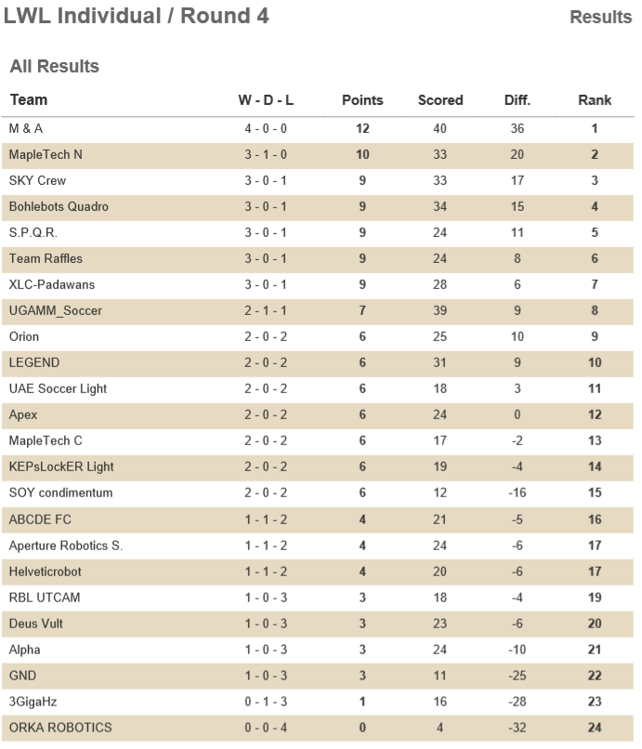

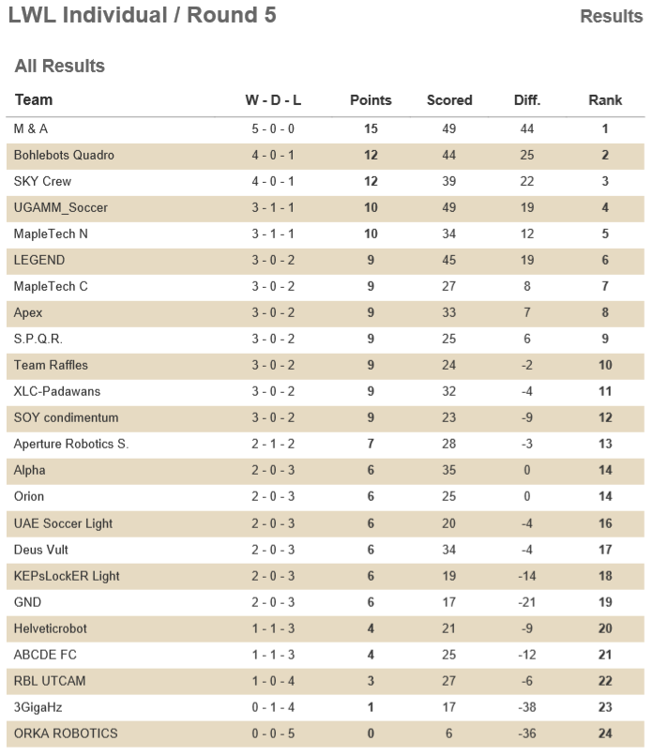

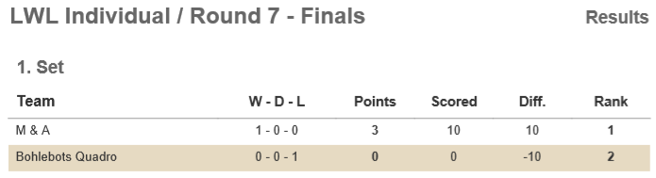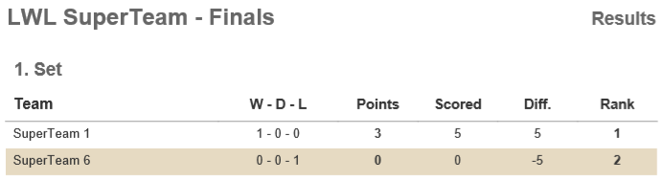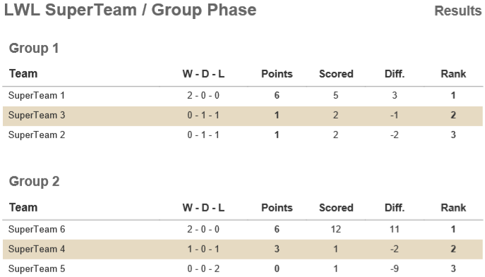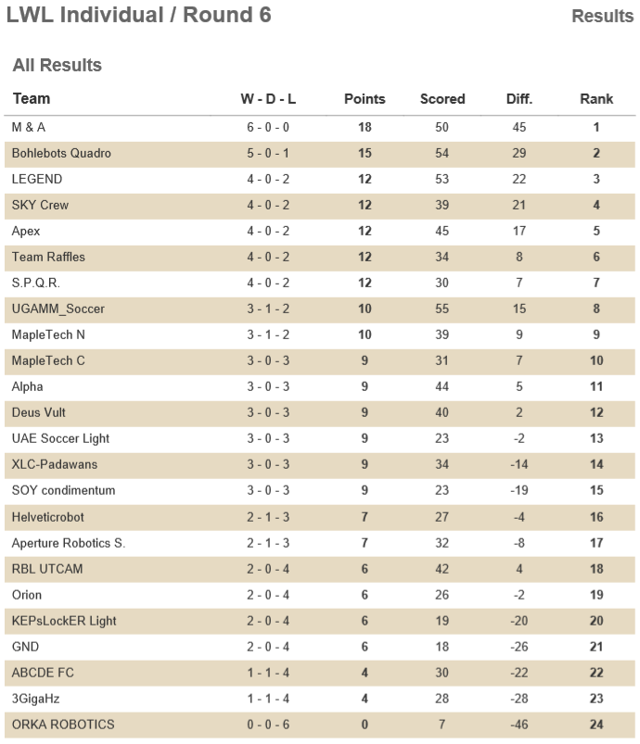

**Describe the organisation of the event**

The event was organised well, the games were on time and the fields were good (the goals were too short, at 80mm, which actually made it better for us.) The awards ceremony was not too good however.

**Describe the inspection process and requirements**

The inspection was fairly strict. I’m not sure if they had a rule on going 10 grams over the weight limit as this wasn’t an issue. They made you cover anything the same colour as the goal, no matter how small it was.

**Describe your workspace**

Our workspace was a large table with 4 chairs. It also had a power hub attached to it that had 4 power points, a usb port and usb-c port for charging. Our Superteam members weren’t seated near us, so we made a time to briefly meet and exchanged emails to talk that night. Our Superteam had teams from Israel, Singapore and Taiwan. Our superteam didn’t have any strategies. There was no Superteam interview. We beat all teams, however we had a very close match with Skycrew.

**Intel on other teams**

Skycrew along with some other teams employed aluminium plates approximately 1mm thick that were very lightweight and strong. Some teams also had lightweight solenoids. Bohlebots incorporated one that weight ~17 grams. They used 0.8mm wire wound around the body that was 30mm long, twice. They claimed that it would kick ¾ of the ramp, although I never saw it kick in game. Legend had a dribbler on their robot that consisted of a brushless motor and a roller bar. Their roller bar had not centre gap to centre the ball, and our robot would often hit the ball out quickly. They didn’t have any apparent strategy with it so I didn’t really get to see it in action. The dribbler can be seen in our game against LEGEND.

**Our team’s strengths and weaknesses**

We experienced very few issues. At the beginning of the competition our Open-MV began to power cycle because of an issue with the headers. This was fixed by hard-wiring its power into the voltage regulator. Aside from this, and having to tighten some bolts throughout the competition, our robots were very reliable. This was caused largely because of the lack of external wiring and strong construction after an emergency update to our top plate. We achieved our result because we had robots that were extremely consistent. Our goalie also meant that even with one robot off the field, we rarely had a goal scored against us. Our attackers tuning was also very effective when combined with the robot’s speed. This meant that our robots were at the ball first almost anywhere on the field.

**Improvements for BBC**

More production routes would definitely help in our robots quality. Being able to use materials such as aluminium and carbon fibre more freely would allow us to have more weight left over and have stronger robots. Extra weight would allow us to have more functionality in our robots, with things like dribblers, kickers and extra sensors. Taking some time to look into cheap routes of machining both carbon fiber and aluminium would be worthwhile for improving our robot’s performance. A kicker is used by some teams, most commonly in the form of a solenoid, however some teams used a motor with an arm on it to flick the ball. A kicker however probably wouldn’t help our robots be more effective, as they’re already fast, and a kicker only makes the ball move in a straight line which means that if the other team has a goalie it would be the same difficulty to stop. The ball would also likely slow down to the point where our robot would reach it again very quickly. For this reason, a lightweight team and some open teams use a dribbler which allows the robot to make different shot, possibly curving the ball into the goal, or driving to the goal backwards and turning quickly.